NAO Data Science Internship – Technical Exercise

Name: Muhammad Yousuf

Task: Greenhouse Gas (GHG) Emissions Analysis and Forecast

Date: 25-01-2025

Table of Contents

1. Introduction and Data Summary 3

Data Cleaning and Processing: 3

2. Modelling Approach 3

Historical Trend Analysis: 3

Forecasting Technique: 3

3. Findings 4

Historical Trends: 4

Forecast (2024–2028): 4

Industry Based Findings: 4

4. Visualisations 5

Figure 1: Historical GHG Emissions (1990–2023): 5

Figure 2: 5-Year Forecast (2024–2028): 5

Figure 3: Historical GHG Emissions by Industry (1990-2023): 6

5. Implications for the UK Government 6

Policy Effectiveness: 6

Sectoral Contributions: 6

6. Limitations and Recommendations 7

Limitations: 7

Recommendations: 7

7. Conclusion 7

**Greenhouse Gas (GHG) Emissions Analysis and Forecast**

# 1. Introduction and Data Summary

This analysis focuses on annual greenhouse gas (GHG) emissions in the UK from 1990 to (provisional) 2023, leveraging data sourced from the UK's Office for National Statistics. The primary objective is to study historical emissions trends and project emissions for the next five years (2024–2028). This work provides crucial insights into the efficacy of current policies and identifies areas for strategic improvement to meet the net-zero emissions target by 2050.

### Data Cleaning and Processing:

The dataset comprised emissions figures across multiple economic sectors in thousand tonnes of CO2 equivalent. The key preprocessing steps included:

* **Excluding Non-Relevant Data**: Metadata and headers from the first seven rows of the original sheet were removed.
* **Summarising Annual Totals**: Emissions across all sectors were aggregated annually to derive total emissions for each year.
* **Handling Missing Values**: Provisional figures for 2023 were retained, but no gaps or null entries were found after data cleaning.

The cleaned dataset, spanning 34 years, was analysed and used as a foundation for visualisation and forecasting.

# 2. Modelling Approach

### Historical Trend Analysis:

A line chart was created to display historical emissions trends (1990–2023). The data reveals a significant and consistent decline in GHG emissions, highlighting the UK’s commitment to decarbonisation. (See Figure 1.)

### Forecasting Technique:

The **Holt-Winters Exponential Smoothing model** was used to predict emissions from 2024 to 2028. This approach was chosen due to its effectiveness in capturing long-term trends and handling non-seasonal data. The model assumes:

* Past trends will persist in the near future.
* External shocks (e.g., policy changes, economic disruptions) are not accounted for.

# 3. Findings

### Historical Trends:

* Emissions decreased from approximately **842,320 thousand tonnes in 1990** to **486,822 thousand tonnes in 2023**.
* The steepest reductions occurred between 2001 and 2015, driven by transitions to renewable energy, energy efficiency improvements, and reduced reliance on coal.
* The rate of decline has slowed in recent years, suggesting diminishing returns from current strategies.

### Forecast (2024–2028):

* The forecast predicts a continued decline in emissions, reaching **approximately 430,000 thousand tonnes by 2028**.
* This suggests a steady downward trend, though the forecasted plateau signals the need for additional interventions to maintain progress.

### Industry Based Findings:

#### Promising Declines:

**Electricity, Gas, Steam, and Air Conditioning Supply** and **Water Supply** showed the largest reductions in emissions, followed by **Manufacturing**.

#### Minimal Decline:

Sectors like **Customer Expenditure (Travel)**, **Activities of Households**, and **Agriculture** showed limited reductions, requiring more focus.

#### Increased Emissions:

**Construction**, **Accommodation and Food Services**, and **Real Estate** saw the largest increases, highlighting areas needing urgent attention.

# 4. Visualisations

### Figure 1: Historical GHG Emissions (1990–2023):

Displays a consistent decline in emissions over time, emphasising the impact of past policies.

Figure 1. UK GHG Emissions: Historical Data (1990-2023)

### Figure 2: 5-Year Forecast (2024–2028):

Shows the projected downward trajectory, highlighting the necessity for further policy and technological advancements.

Figure 2. UK GHG Emissions: 5-Year Forecast (2024-2028)

### Figure 3: Historical GHG Emissions by Industry (1990-2023):

Figure 3. UK GHG Emissions by Industry (1990-2023)

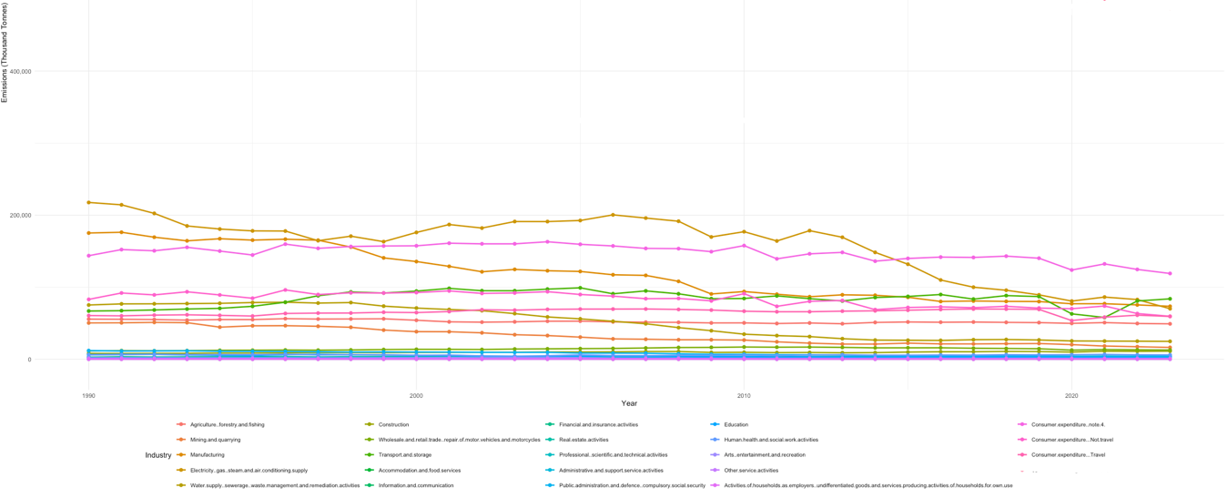

# 5. Implications for the UK Government

### Policy Effectiveness:

* The historical data indicates the success of policies promoting renewable energy, industrial decarbonisation, and efficiency improvements.
* However, achieving net-zero by 2050 will require:
  + Accelerating renewable energy adoption and infrastructure development.
  + Strengthening incentives for carbon capture and storage (CCS) projects.
  + Expanding funding for R&D in emissions reduction technologies.

### Sectoral Contributions:

**Transport and Storage**:

* Accelerate adoption of electric vehicles and expand charging infrastructure.
* Promote freight electrification and develop alternative fuel solutions for aviation and shipping.

**Construction and Real Estate**:

* Mandate green building standards for new construction.
* Introduce incentives for retrofitting older structures with energy-efficient technologies.

**Agriculture**:

* Increase adoption of sustainable farming practices, such as precision agriculture and methane-reducing feed.

**Consumer Behaviour**:

* Launch campaigns to promote low-carbon travel options and energy-efficient lifestyles.

# 6. Limitations and Recommendations

### Limitations:

* The Holt-Winters model assumes stable trends, limiting its applicability if unexpected events (e.g., major policy shifts) occur.
* Provisional data for 2023 introduces some uncertainty in the analysis.
* Sector-specific emissions patterns were not modelled separately, which could provide more granular insights.

### Recommendations:

* Adopt advanced modelling techniques like ARIMA or machine learning algorithms for higher precision and adaptability.
* Continuously update models with new data to reflect emerging trends and unforeseen disruptions.

# 7. Conclusion

The analysis highlights significant progress in reducing emissions, particularly in the energy and manufacturing sectors. However, emissions from transport and construction remain critical challenges, while agriculture and consumer behaviour require focused efforts to achieve meaningful reductions. Addressing these sectors with targeted policies, technological innovations, and public awareness campaigns will be essential to achieving net-zero emissions by 2050. Collaborative action across all levels of society is key to sustaining the UK's leadership in climate action.  
  
By building on past successes and addressing emerging challenges, the UK can reinforce its position as a global leader in emissions reduction and climate resilience.